Indian School of Business

Data Visualization

Instructor:

Dr. John F. Tripp, Clemson University, [jftripp@clemson.edu](mailto:jftripp@clemson.edu)

# INDIVIDUAL Assignment

SEE LMS FOR DUE DATE

**ASSIGNMENT TYPE: 3N-b**

You **MAY NOT** discuss general concepts and ideas relevant to the assignment with others

You **MAY NOT** discuss specific issues associated with the assignment with others

You **MAY** refer to external material

You **MAY NOT** case-study solutions or problem set solutions

The goal of this assignment is to determine your level of ability using Tableau, and to apply the theoretical perspectives taught in the course. To test this, you will create a visual data story in Tableau. The key requirements are:

1. A Tableau Story that narrates your message in a way that you do not have to be present to explain the visualization. In short, you should be able to send me the story, and I should have complete understanding of your message with no further information.
2. You must deliver the story using a Tableau packaged workbook (.twbx).

There are TWO PARTS:

**PART 1: Public Health Dashboard – Extending Hans Rosling.**

For this option, you will first re-create Hans Rosling’s Gapminder visualization that we viewed previously (<https://youtu.be/usdJgEwMinM?t=2m41s>).

To do this, you will import the four text files that are posted on LMS into a new **TABLEAU PACKAGED WORKBOOK.** You will need to properly join the data as per the following instructions:

*Countries by Continent* joins with *Life Expectancy* by the **Country** field.

*Fertility* joins with *Life Expectancy* by the **Country** and **Year** fields.

*Population* joins with *Life Expectancy* by the **Country** and **Year** fields.

NOTES:

1. Make the country circles partially transparent so that you can see when countries are overlapping.
2. Tableau tries to automatically link your data sources – often you just have to tell it to use the links, BUT make sure that you blend on the right fields, or you will get days-long queries.

When you finish, your Rosling sheet should be able to generate a visualization that looks something like this:

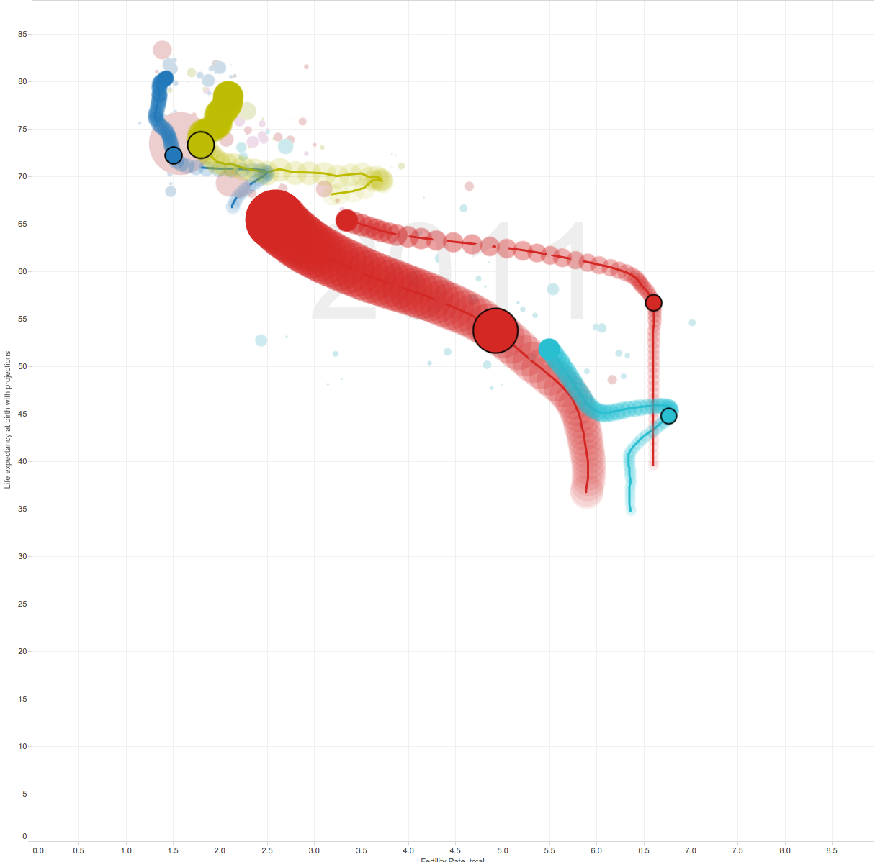

Finally,

* Add the GDPData.xls to your data source.
* Include the GDP data as part of a TOOLTIP in your Rosling Chart.

**Part 2: RECREATE this dashboard**

TASK: Duplicate the following Dashboard using Coffee Chain data to show profitability

Instructions:

1. Connect to Coffee Chain dataset PROVIDED ON LMS.
2. Four worksheets are needed - Total Sales, Sales Map, Sales by Product Type and Sales by Market
3. A Summary dashboard also needs to be created as shown above.
4. The first worksheet which is Total Sales is a representation of the total sales for the entire superstore data set. There should be five measures as shown in the dashboard(Sales, profit, Profit Per order, Sales Per Product, Margin and Total Expenses)
5. The Second worksheet(Sales Map) is a representation of the aggregate of profit ratio represented In a map
6. The Third worksheet(Sales by Market) is a trend of the Sales by Market for profitable and unprofitable orders across years 2012-2014
7. The Fourth worksheet(Sales by Product Type) is a trend of the Sales by Product Type for profitable and unprofitable orders across years 2012-2014
8. Your visualization must show that you understand the principles of visual perception.
9. Your visualization should be visually beautiful, simple to understand, and compelling.

Part One: 50%

Part Two: 50%